**Pizza sales SQL queries**

Kpi’s

Total revenue

SELECT sum(total_price) as total_revenue from pizza_sales

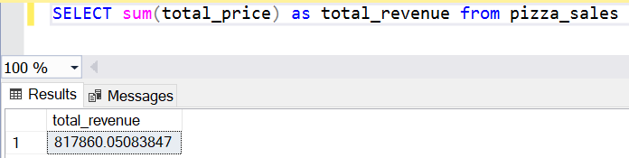

Average order value

Select SUM(total_price) / COUNT(distinct order_id) as Avg_Order_Value from pizza_sales

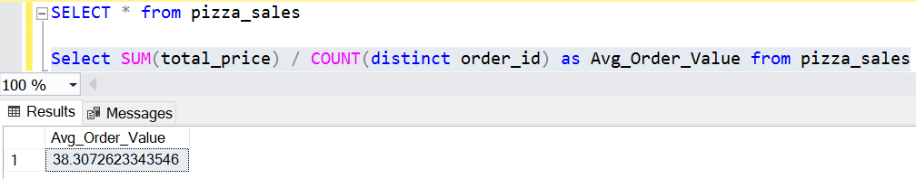

Total pizza sold

select sum quantity as total_pizza_sold from pizza_sales

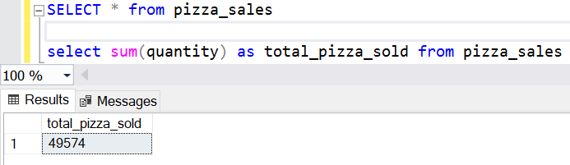

Total orders

select COUNT(distinct order_id) as total_pizza_sold from pizza_sales

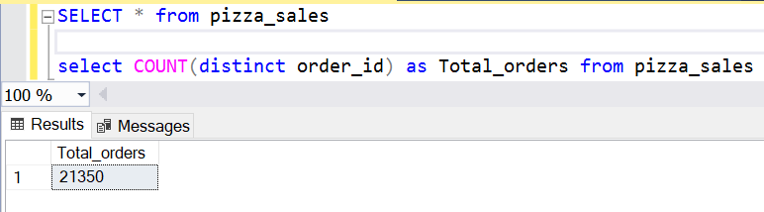

average pizzas per order

select cast(cast(sum(quantity) as decimal (10,2)) /

cast(COUNT(distinct order_id)as decimal (10,2))as decimal(10,2))

as Avg_pizzas_per_order from pizza_sales

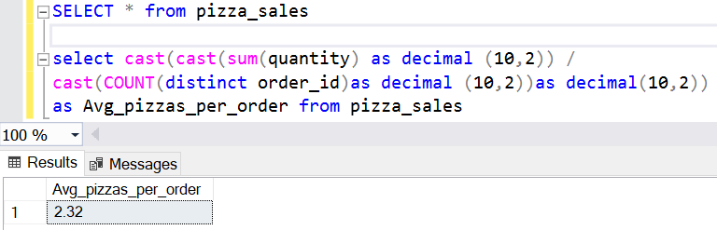

Daily trend

select DATENAME(DW, order_date) as Order_Day,

COUNT (distinct order_id) as Total_orders

from pizza_sales group by DATENAME(DW, order_date)

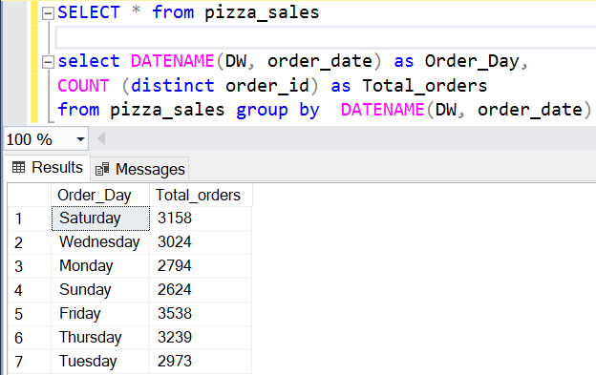

Monthly trend

select DATENAME(MONTH, order_date) as Order_Month,

COUNT (distinct order_id) as Total_orders

from pizza_sales group by DATENAME(MONTH, order_date)

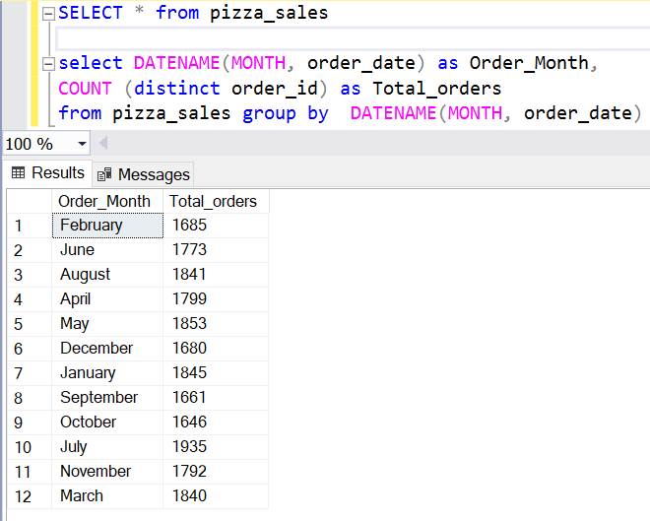

8. percentage sale by category

select pizza_category, Sum(total_price) * 100 /

(select sum(total_price) from pizza_sales)

as Total_Revenue_PCT from pizza_sales

group by pizza_category

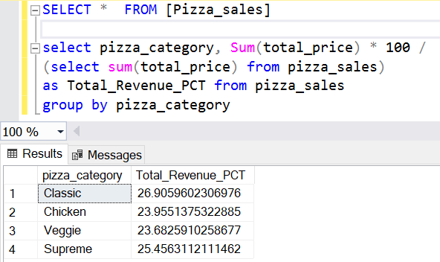

9. percentage sale by pizza size

select pizza_size, cast(Sum(total_price) * 100 /

(select sum(total_price) from pizza_sales) as decimal(10,2))

as Total_Revenue_PCT from pizza_sales

group by pizza_size

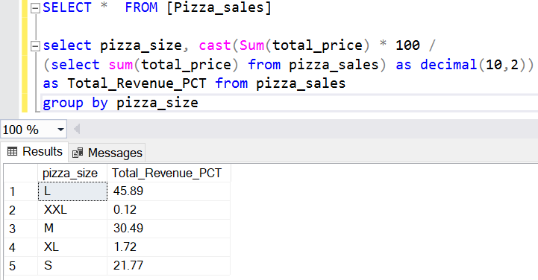

10.top 5 best sellers by revenue  
select top 5 pizza_name, sum(total_price)

as Total_Revenue from pizza_sales

group by pizza_name

order by Total_Revenue desc

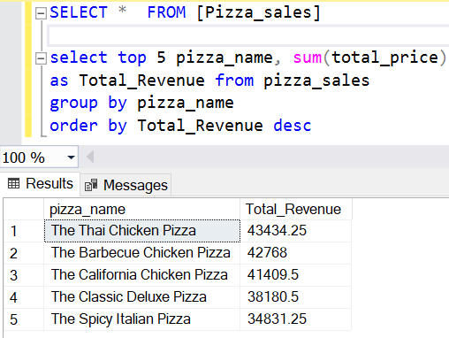

11. bottom 5 best sellers by revenue

select top 5 pizza_name, sum(total_price)

as Total_Revenue from pizza_sales

group by pizza_name

order by Total_Revenue asc

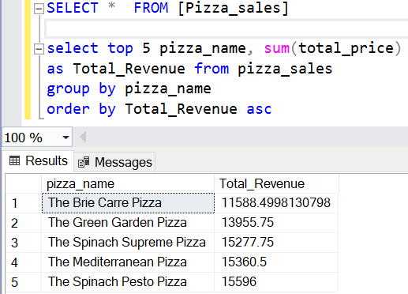

12. top 5 best sellers by quantity

select top 5 pizza_name, sum(quantity)

as Total_quantity from pizza_sales

group by pizza_name

order by Total_quantity desc

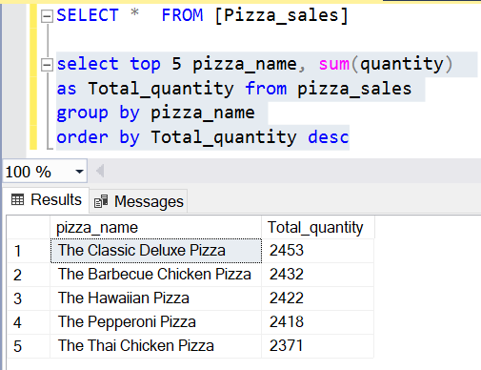

13. bottom 5 best sellers by quantity

select top 5 pizza_name, sum(quantity)

as Total_quantity from pizza_sales

group by pizza_name

order by Total_quantity asc

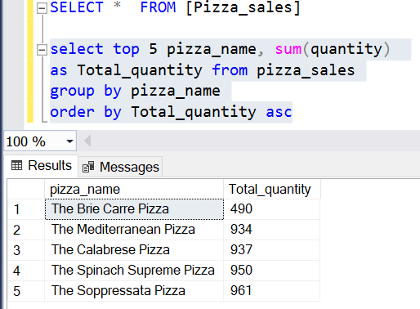

14. top 5 best sellers by orders

select top 5 pizza_name, count(distinct order_id)

as Total_Orders from pizza_sales

group by pizza_name

order by Total_Orders desc

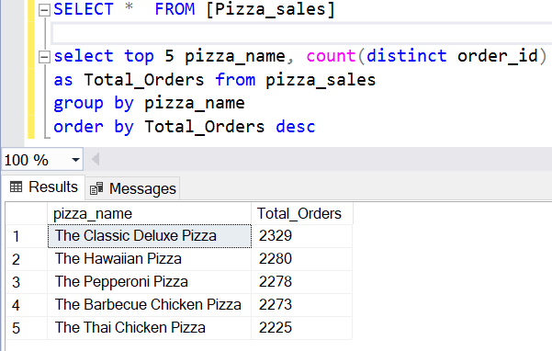

15. bottom 5 best sellers by orders

select top 5 pizza_name, count(distinct order_id)

as Total_Orders from pizza_sales

group by pizza_name

order by Total_Orders asc

